Magic Invitational Report: Darwin Kastle
Darwin Kastle
I'm very lucky. I've been invited to four straight Invitationals. I know some players who seem to just view the Invitational as a vacation. Over the years, I have tried to be prepared to compete at a high level and I like to think that has been reflected by my success, especially in Constructed.
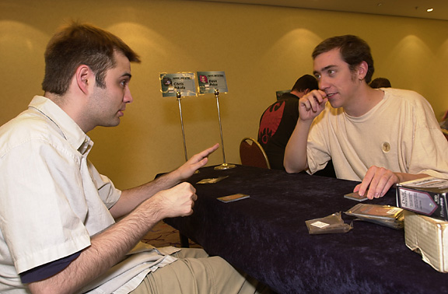
I was excited when I learned this year's event was being held in Sydney. I have long dreamed of traveling to Australia. Visions of sunny beaches, Koala bears, and Aussie accents had filled many childhood dreams.
I was in for an unpleasant surprise. Oh the rain! It rained or was overcast every day I was in Australia. This led to me seeking indoor entertainment.
My next unpleasant surprise came when I arrived at Sega World to find out that it had closed its doors for good mere days before my arrival. I eventually settled on the Darling Harbor Imax Theater to provide much of my entertainment. This was fine since I love movies and these films were being shown on the biggest screen in the world. I recommend "Alien Adventure" (in 3-D!) to anyone who enjoys roller coasters (it made me nauseous).
Of course, I also played some Magic while in Sydney. The tournament was held at the hotel WotC was putting us up at, the Star City hotel and casino. The hotel had nice rooms and even nicer restaurants.
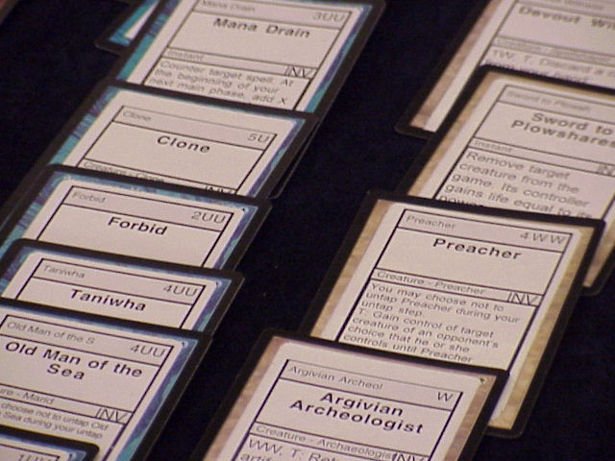
The first format was Duplicate Sealed. This format has evolved from my best format to my worst over the years. One of my strengths as a player is the ability to play with a set and quickly evaluate the strength of various cards in Limited. In Rio, we were given a pool of strong Limited cards that we were already familiar with to make our decks. The intimate knowledge I had of the comparative strength levels of those cards for Limited was of great use to me. The time I had spent playing with those cards over the years helped me in making the strongest deck. I went 4-0 in sealed at Rio (that includes the finals).
Duplicate Sealed has been very different since Rio. The card pools have consisted mainly of cards that were too weak to have been used much in Limited and cards that were invented for the Invitational. Now my knowledge of various cards in Limited was of little aid. Still, I can look at what a card does and its casting cost, and develop a good idea of how strong it is. The other big change is the number of combos included in the card pool. Looking for subtle combos in the card pool is not a big part of normal Limited play. Normally the main issues are selecting your best creatures and creature removal and making sure your mana and your mana curve are good. This approach is not effective enough with these card pools. This is further complicated by the fact that you are often looking for combos with cards that you have never seen or used before. Some Invitational players have thrived in this environment. I am not one of them. I was 2-1 in Barcelona, 1-2 in Kuala Lumpur, and 0-3 in Sydney. I see this format as being an interesting one to follow on the internet so I accept it, but it presents me with a challenging hurdle on my way to Invitational success. My pleasure at being part of the Invitational would be hard to diminish no matter what formats I had to play.
My lucky (and clever) Sealed opponents this year were Trevor Blackwell, Bob Maher, and Gary Wise. The card pool didn't include any new cards, but it did use new casting costs for everything. Trevor beat me 2-0 in part due to his cool Aladdin/Thran Forge combo. Both games against Bob I was hurt badly by my own creation, Avalanche Riders. Ironically, while all three of my opponents cast them against me, I wasn't even using Avalanche Riders. While I managed to force a game 3 against Gary, he took what had looked like a favorable game three away from me with the combination of Goblin Bombardment and Tombstone Stairwell.
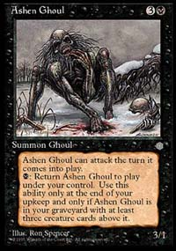
Having never been down 0-3 at an Invitational before, I tried to pull my spirits back up for the next format, Bring Your Own Block. I played with Ice Age, Urza's Legacy, and Exodus. I built my deck around one of my signature cards, Survival of the Fittest, and included four of another one, Avalanche Riders. I was happy because not only could I use some of my favorite cards and make my deck fun to play, but the deck was good also. It was a four-color deck using Survival, Oath of Ghouls, Ashen Ghouls, and utility creatures.
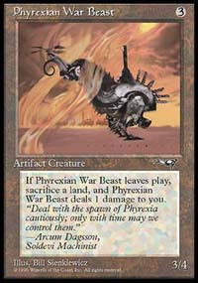
My first opponent was Gerardo Godinez, who was playing Ponza, a mono-red beatdown, and land destruction deck. Game one, my Survival got me two Radiant's Dragoons and a Lhurgoyf, which he was unable to deal with. Game two I got a light mana draw and two Stone Rains, a Pillage, and a Wasteland completely shut me down. Game three was weird; Gerardo got badly mana screwed and because I was badly mana flooded, I couldn't apply the pressure to take advantage of it. While I sat there with lots of land and not much to do (Gerardo had used Pyrokinesis to kill my only threats), Gerardo started to draw land and start putting the pressure on me. The turn before he would have killed me, I drew a Deranged Hermit and then an Oath of Ghouls allowing me to stabilize. The decisive play of the game turned out to be when I Swords to Plowshared his Phyrexian Warbeast, which destroyed one of his lands and prevented him from being able to cast Apocalypse.
After that close call, I found out I was to play Chris Pikula, and for the second year in a row he would be facing me with a mirror match because he had received help from me (last year my teammate Dave) on his deck. This year had a much more satisfying result for me however. Last year was the randomness of Type I Trix vs. Trix, this year I welcomed Chris to MY HOUSE!
From my perspective, the match was fought and decided in Chris's head in game one. We both got turn two Survival, I mana stalled at two land and he had some things to get which I didn't have (extra Hermit and extra Ghouls). I thought things were fading out of reach as Chris Avalanche Ridered me while I was land stalled and I knew there were 3 more where that came from. The combination of Fyndhorn Elves and Yavimaya Granger helped me enough to convince Chris not to bother getting a second Rider. The problem for Chris was he didn't have a good new plan of attack. Chris's new plan was to follow my lead. I was only too happy to take the initiative and be the first to have a Phyrexian Plaguelord in play. I knew victory was mine as I listened to Chris explain his predicament to the whole room. Chris explained that our draws were the same except that I was mana screwed and now I was winning. With game one still in progress, Chris proclaimed that he had never been so outplayed in his life. That Chris, what a charmer! Game two seemed almost predetermined, given his state of mind.
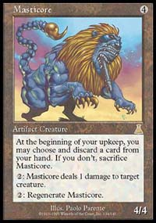
Next up was Yoshikazu Ishii. He was playing a scary Fires of Yavimaya deck with the added power of cards like Masticore and Powder Keg. Game one, Spike Weaver held him at bay early until I got my Survival and then came Dragoons, Plaguelord, and Hermit. The Plaguelord was key because it was my only main deck answer to Masticore.
Game two was pretty scary. Yoshikazu's deck unleashed threat after threat; his draw would have certainly beat most decks and probably mine before sideboarding. I faced what seemed like an endless stream of Blastoderms, Saproling Bursts, Masticores, and Kavu Chameleons. Fortunately my Ice Age heavy sideboard supplied me with a Disenchant for his first Burst, and Swords to Plowshares for his Masticores. Radiant's Dragoons kept me in the game long enough for a gigantic Lhurgoyf to take over the game from his suddenly not so large creatures. After starting out 0-3, I was pretty happy to be 3-3 at this point. The next format was Solomon Draft, which I consider a good format for me in part because I think I play it more than most people. It also has helped that the card pools haven't included made up cards. While I went 1-2 this year, I still feel this a good format for me.
My draft with Ben was close because he also Solomon Drafts more than most people. The match went to three games and I feel that I blew game three (with some help from good play from Ben) in part because I drew so many good cards I couldn't decide what strategy to use.
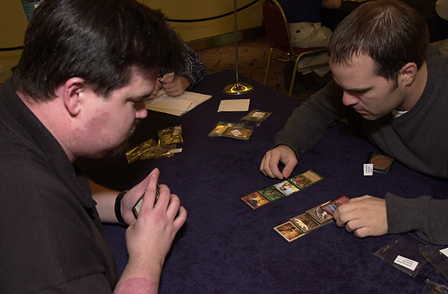
Round eight my opponent was Mike Long. After drafting circles around him for the second year in a row, I can tell this isn't one of his strongest formats. I let him have most of the powerful late game creatures like Mageta, Jorael, and Reya, while I hogged the good early creatures like Barrin, Master Wizard and the removal spells like Agonizing Demise and Dark Banishing.
Game one a bad mana draw and the fact that Mike's deck was slow enabled me to completely shut him down with Barrin and Ertai. Game two an early Zuran Enchanter forced Mike to empty his hand and I then cleared the board with a Breath of Darigaaz. While I have never gotten better than a draw against Mike on the Tour, I'm happy to have his number at Invitationals.
Round nine I played Noah Boeken, whom is also pretty familiar with the format. He may have outdrafted me, due in part to the fact that I made bad piles in the last set as I was racing against time. Game one he decked me with a Grindstone that kept double grinding me despite the fact that I was playing three or four colors. Game two my draw was full of high casting cost creatures and he ran me over with early creatures.
The Auction turned out to be a lot more fun than I had expected. I assigned values to all the decks and refused to bid past those values. This stubbornness left me in at the end, with a choice between Olle Rade's deck and Sigurd Eskeland's deck. I felt that there were too many decks with artifact mana and creature mana to play Waters, and I felt Olle's deck might be good in an environment where people were starting with less than 20 life. So I played the Spider deck with 20 life and 7 cards.
Olle Rade
Pro Tour Columbus '96 (61 cards)
Main Deck |  | Sideboard
Creatures (21)  4 Deadly Insect  4 Fyndhorn Elves  4 Giant Trap Door Spider  1 Gorilla Shaman  2 Orcish Cannoneers  2 Storm Shaman  4 Wooly Spider  Spells (22)  2 Giant Growth  4 Incinerate  1 Jokulhaups | 2 Lava Burst  2 Lodestone Bauble  3 Pillage  1 Pyroclasm  3 Stormbind  4 Urza's Bauble  Land (18)  4 Karplusan Forest  7 Forest  7 Mountain | 1 Anarchy  2 Essence Filter  1 Icy Manipulator  1 Jester's Cap  1 Jokulhaups  1 Monsoon  1 Primitive Justice  2 Pyroblast  2 Pyroclasm  2 Vexing Arcanix  1 Zuran Orb
Round ten I played my roommate Alex. Alex was a great roommate, but I delivered the beats anyway. The fact that he was playing with Wildfire was scary, but his draws were bad and mine were good and that was the end of it. I found Olle's deck had plenty of mana, I just wish there were some more one or two casting cost creatures.
Round eleven was very ironic. I was playing beatdown vs. David Price playing with Survival/Recur. Another scary matchup, I felt the key was that he started with 14 life, because every game I finished him off just as he was about to take control.
Round twelve my good luck ended vs. Kai Budde playing his own Wildfire deck. Both games looked good until Kai took control with a Wildfire. I was happy going 2-1 with "Bug Bind" and heading into Type I at 6-6.
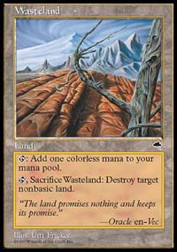
Round thirteen I played "the King" Jon Finkel. I'm one of many people who believe Jon is the best Magic player to ever pick up a deck. I've played Jon many times over the years and have many memorable wins and losses, but every win against Jon gives me a sense of accomplishment. Jon mana stalled in Game one after I double Wastelanded him and my aggressive 4-color Sligh deck was unforgiving. Game two, I mana stalled after Jon double Wastelanded me, but two Jackal Pups went the distance for me, while I sat with no land in play.
My last two matches were both very close and both went to three games, but I could tell Zvi was more practiced with his deck and with Type I than Ryan Fuller was. While Zvi managed to pull out a tight match, Ryan seemed to make some questionable plays in game 3 that allowed me to steal victory from the jaws of defeat.

Because I started out 0-3, I am reasonably happy with my 8-7 fifth place finish, especially when you look at the competition. This is my second fifth place since they started giving trophies to the top four finishers, so I hope to have the opportunity to improve my finish by being invited to next year's event. I would also like to thank WotC for introducing me to Mongolian buffets and I recommend them to everyone (except vegetarians). I play Magic for a living now, so keep your eye out for me at Grand Prix and on the net. Until then, may the Magic gods smile on you all.
Darwin Kastle

